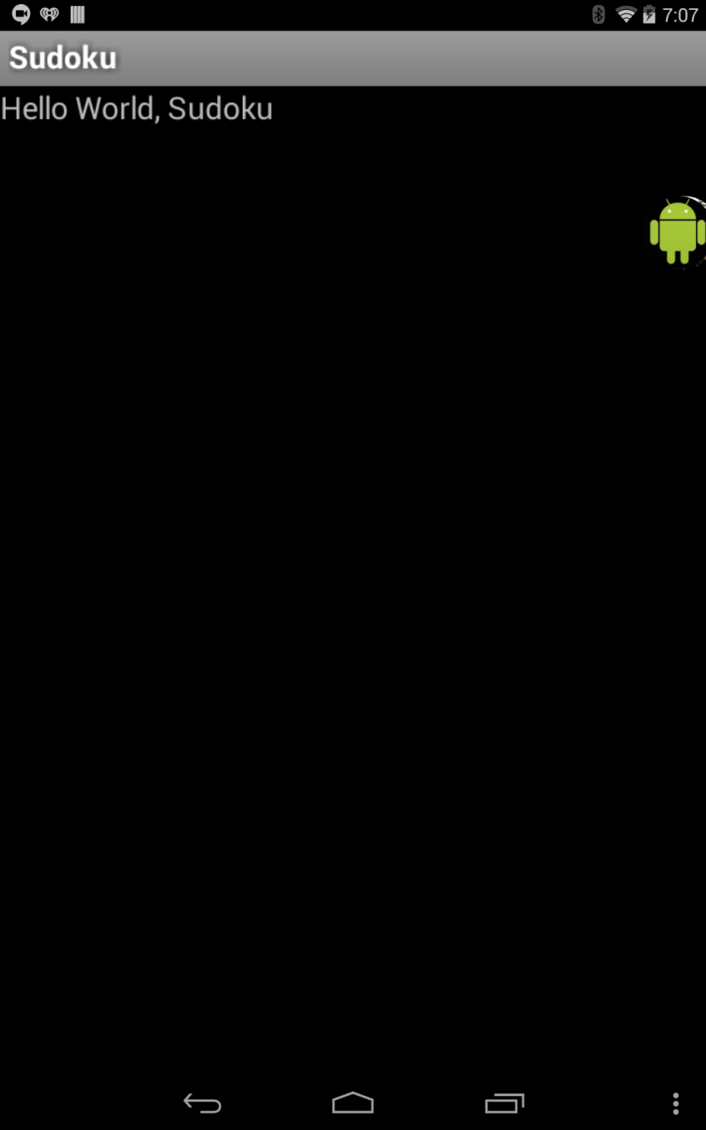

**Sudoku v0:**

In this version of code, all that is printed out is “Hello World, Sudoku.”

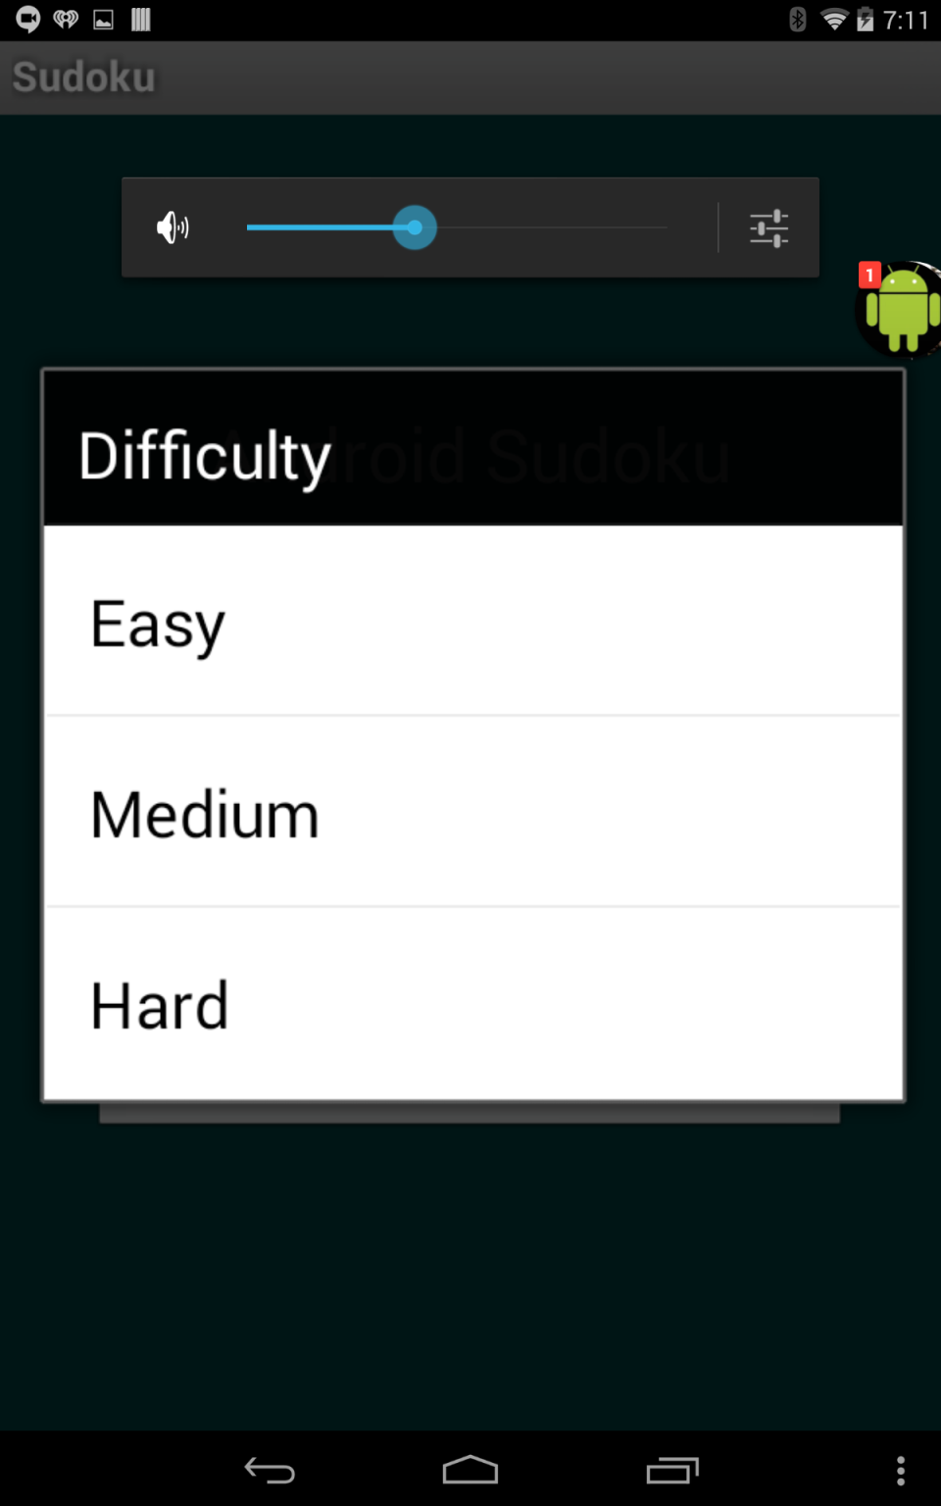

**Sudoku v1:**

In this version, 4 buttons are created: “About,” “Continue,” “New Game,” and “Exit.” There is also a settings tab, which can be accessed by clicking the three circles in the bottom right corner. However, the two buttons do not work in this tab. Also, only the “Exit” button, which exits the app, and the “New Game” button, which opens a menu asking for the difficulty of the game. However, you cannot continue from this menu; all this button does is simply show this menu; users cannot proceed from this screen.

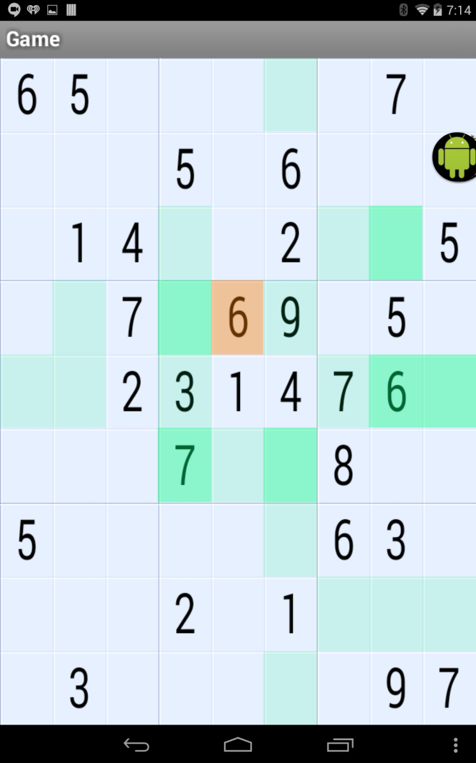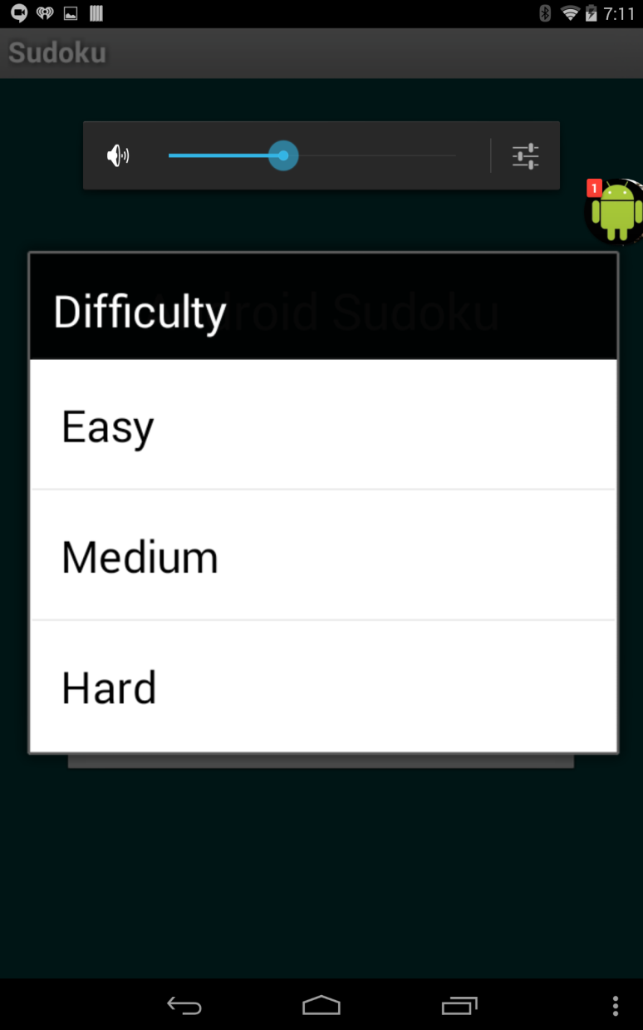

**Sudoku v2:**

This version accomplishes the same capabilities of v1, but in this version users are able to create a game with their own difficulty of their choosing.

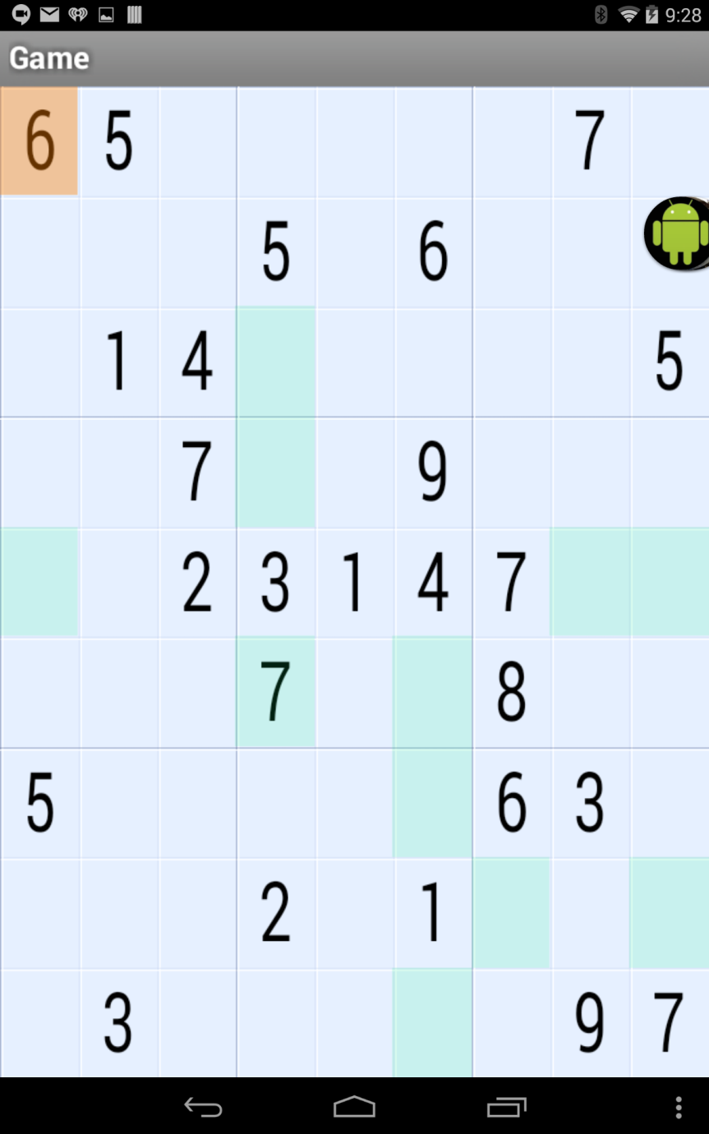

**Sudoku v3:**

In this version, music is added to the application. There are two different mp3s playing however. There is a different mp3 being played when the Sudoku application is on the menu screen, and there is a different mp3 being played when the Sudoku application is on the Sudoku game. However, you cannot toggle the music off and on in your settings.

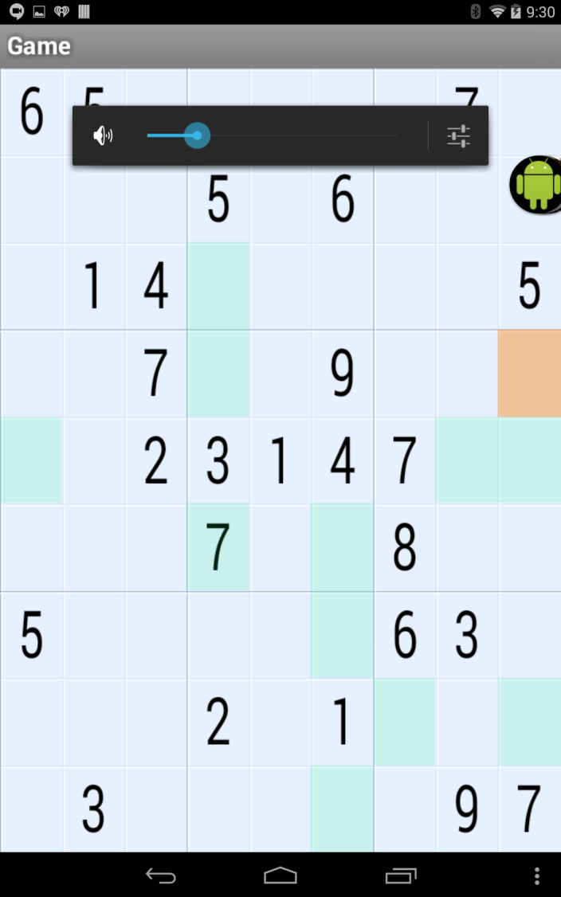

**Sudoku v4:**

In this version, the “Continue” button in this app works, allowing the user to continue a saved game. In the settings tab, both the buttons work, allowing the user to toggle the music off and on and turn off the hints.

**Changes in the code of Sudoku4:**

Changed the color of the background of the menu screen, changed the color of the cells in the Sudoku puzzle, and I changed the music played when the Sudoku puzzle is the current screen.